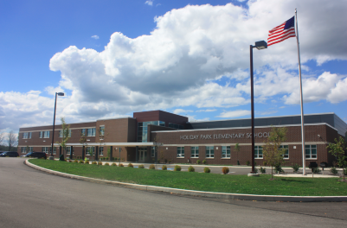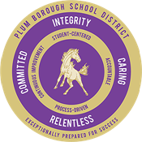 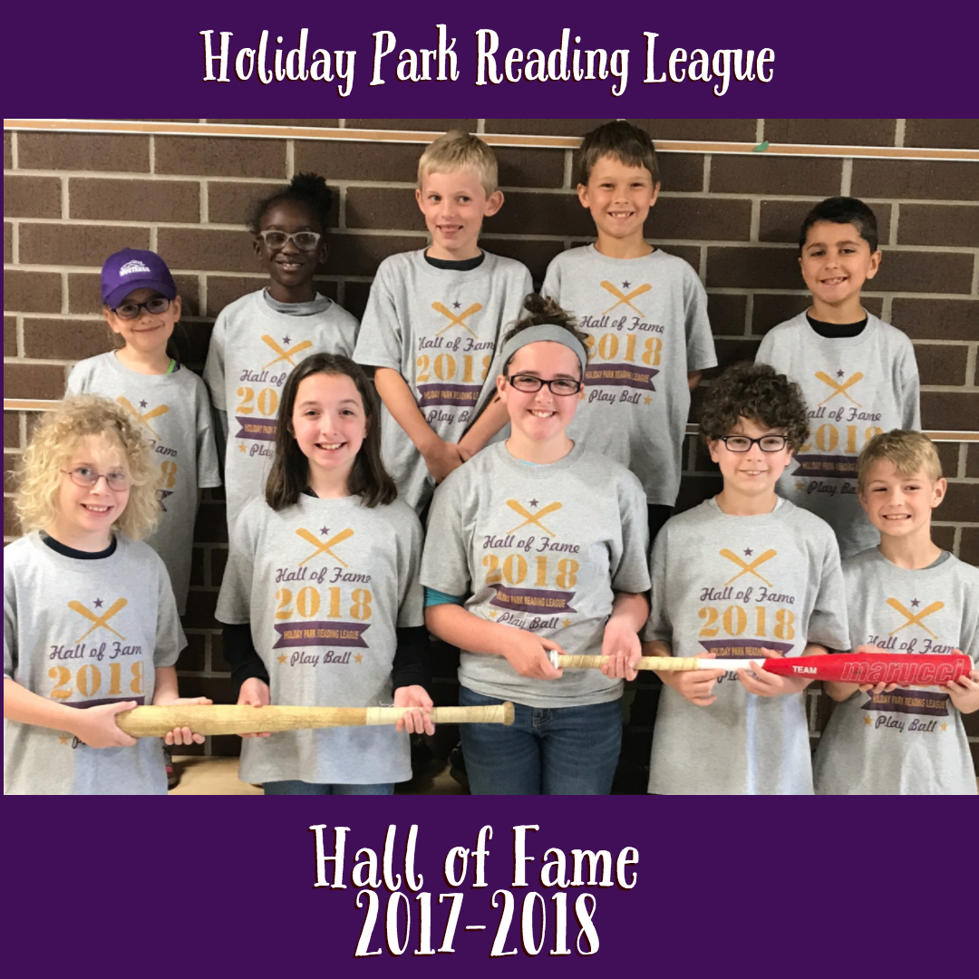

* MVP Reader - Each Month/ Every Class/ Chosen by Homeroom Teacher
* 100 Point Club
* Hall of Fame – Elite Readers
* Grade Level Announcements
* School Wide Challenges

**How will students be motivated**

**for success in this program?**

**Your child will be participating in the Accelerated Reader™ program.**

*Monitors your child’s independent reading practice through a computer based system.

*Allows your child to select and read a book of interest at his/her level and complete a comprehension quiz when finished.

*Allows your child’s teacher to set goals and direct your child to an appropriate readability level, which promotes independent reading instruction.

**What is AR?**

We are all so excited for the 2018-2019 Opening Day for our school wide reading initiative for Holiday Park Elementary!

Holiday Park Reading League has been created to motivate students to read more. To make our program a school wide success, we need everyone on the HPRL team, including students, parents and staff!

**What is our school wide Reading Initiative and goal?**

[Date]

Read together and make reading at home a priority. Help your children pick books that are “just right” and encourage them to take AR Tests to earn points.

The links displayed in the text box, can help you better understand the AR program and will answer any questions you may have. In addition, there are links to help you search and find specific AR books!

**How can I help my child be successful in our Holiday Park Reading Initiative?**

**Congratulations to our**

**HPRL 2017- 2018 Hall of Fame Inductees**

**Parent’s Guide to AR:**

<https://doc.renlearn.com/KMNet/R003985016GG79F2.pdf>

**AR Book Finder**

<http://www.arbookfind.com/>

**Scholastic**

<http://www.scholastic.com/>

**Plum Library**

<http://plumlibrary.org/>

**Resource Links:**

Nunc cursus magna quis